**API 接口设计需求说明**

产品版本：Ver2.0， 2020-2-23

1. Informap staff list: 返回符合筛选要求的staff名单，load informap.html页面的数据。
2. **调用参数：**
   * uid： 用户账号
   * pagetype：用户点击的主菜单页面
   * pagesubtype: 主菜单下一级子菜单，或者dashboard上的图表类型
   * pageselect：用户点击图表的具体内容（主要针对dashboard上的图表）
   * pagefilter：页面元素上的筛选条件（主要针对dashboard上地图）

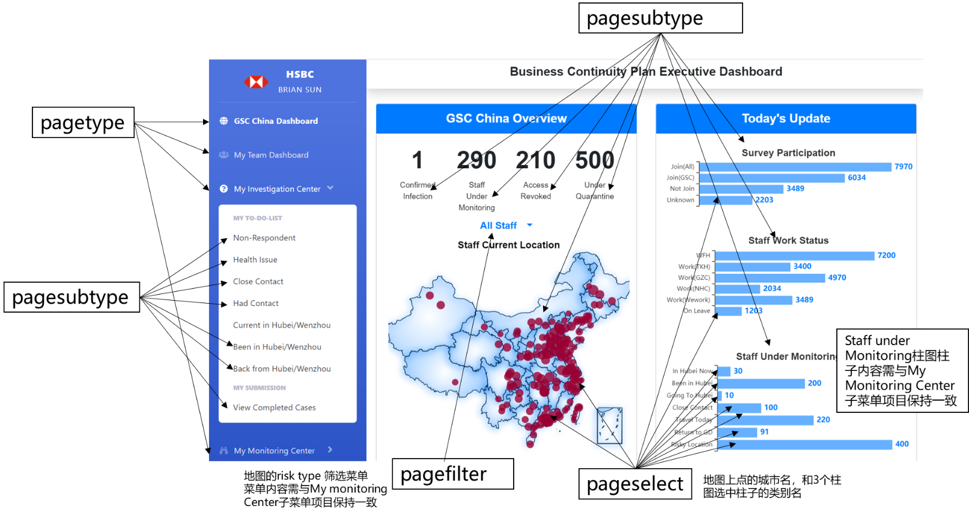

API输入输出规则，详细请见下面的excel附件。



1. **API输出格式：**

{

"staffdata": [

{

"casedate": "05FEB2020",

"caseid": "CA000001",

"casestatus": "Open",

"id": 45209890,

"site": "NHC",

"name": "Tomas Wang",

"mobilephone": 13522897654,

"currentLocation": [113.33388879467501, 23.145579837441266],

"closestRiskLocation": [113.33288879467501, 23.135579837441266],

"currentAddress": "太古汇",

"closestRiskAddress": "天河新作",

"allRiskAddressIn10km": ["天河新作", "车陂街美好居", "龙湖街万科幸福誉"],

"allRiskAddressInLocation": [[113.33288879467501, 23.135579837441266], [113.39346172248892, 23.12532548150483], [113.23213499295431, 23.402198591510476]],

"dist2RiskAddr": 900,

"risktype": "Risky Location",

"revoke": "No",

"revokeReason": "NA",

"vp": "Stephen"

},

{

"casedate": "05FEB2020",

"caseid": "CA000002",

"casestatus": "Under Review",

"id": 45209891,

"site": "NHC",

"name": "Mary Lee",

"mobilephone": 3,

"currentLocation": [113.52884781192102, 23.080374684139],

"closestRiskLocation": [113.53884781192102, 23.0940374684139],

"currentAddress": "南岗街广海路10号",

"closestRiskAddress": "南岗街广海路亨元花园",

"allRiskAddressIn10km": ["天河新作", "车陂街美好居", "龙湖街万科幸福誉"],

"allRiskAddressInLocation": [[113.33288879467501, 23.135579837441266], [113.39346172248892, 23.12532548150483], [113.23213499295431, 23.402198591510476]],

"dist2RiskAddr": 1900,

"risktype": "Been in Hubei",

"revoke": "Yes",

"revokeReason": "No Response",

"vp": "John"

}

]

}